

**USER MANUAL**

*NOTE: This game is played optimally on 1366 x 768 resolution. Any other resolution WILL result in clipping, distortion and a reduced experience.*

Congratulations of purchasing our version of Texas Hold’em Poker! We hope you will have a fun and enjoyable time. If you understand how to play Poker, the program is essentially a no-limit Texas Hold’em Poker game. You, as a player are up against 1 to 3 computer-controlled players. The program runs like a real poker game, with each action taking up 3 seconds. For more about the rules of poker, read ahead. If you are already familiar with Texas Hold’em, feel free to skip to the user interface section.

**How to play poker**

Poker is a game where people bet money on cards. The game consists of analyzing your cards to see how likely you are to win, analyzing enemy actions, and making smart decisions that would get you the most money in the game or keep you from losing money.

**Objective**

Your goal in Poker is to win everyone else’s money. The game ends when one person obtains everybody else’s money and that player wins the game. Hence, you lose the game when you run out of money. You gain all the money people have bet when you win a round by having the best hand on the table, or if everyone else folded.

**Gameplay**

Here is a step-by-step demonstration of how a poker round plays out.

1. Before the game even begins, a **dealer** is chosen at random (for the first match) and will increment to the next player of the current dealer each round. Each new round, the next two players after the dealer pay blinds. Two **hole cards** are dealt to each player (these are cards that only their respective player can see). A **small blind** is first paid then a **big blind**, these blinds count as forced “bets” and serve to make the game progress.
2. The **betting round** begins and from here on each player gets a turn to make a decision. Essentially, players will be betting cards and all other players must match the amount betted. To achieve this, each player can make a type of bet depending on the situation.

Options (types of bets):

**Bet** – Opens the betting if no other player has placed a bet. Any amount you bet must be matched by all other players.

**Check** – Only available when no player has opened the bet yet. If you don’t want to bet either, by choosing this option, you are deciding not to bet.

**Call** – If someone has already opened the bet, you have to match his bet to stay in the match. “Call” means you are betting exactly what you have to bet to stay in the match.

**Raise** – You call and bet an additional amount, raising the stakes. Essentially a call and a bet, so you are betting more than you have to.

**All-in** – You bet all the money you have. This will force all other players to also bet everything or fold. Sometimes when you lose an all-in bet, you will still get money. This deals with side pots and is not something you need to worry as a player as the program will automatically distribute the different pots in the game fairly.

**Fold** – Withdraws from the match (you will be back next match). You will not lose any more money from the moment of fold, but also loses chance to win the match. Some games may end prematurely if all players except one player fold. The remaining player wins the match.

The betting round ends when everyone has had their turn and everyone has the same amount in the pot. Raises increase the length of betting rounds as it would take longer for all players to eventually match the bets.

1. After the first betting round comes the “**flop**” - 3 cards are dealt on the table face-up. All cards on the table are “board” cards, held in common by all players. A Second betting round occurs (reference step 2).
2. After the betting round of the “flop” comes the “**turn**”, where a fourth card is dealt face-up on the table. After the turn, a third round of betting occurs.
3. Then there is the “**river**”, which is where the last (fifth) card is dealt face-up. There is a final round of betting after the “river”.
4. At the end of the match, there is a “**showdown**”, where the players compare their best set of 5 hands to determine the winner(s). The hand values will be explained below.

**Cards**

The cards in poker give value to your hands. From greatest to least valued card RANK:

Ace – King – Queen – Jack – 10 – 9 – 8 – 7 – 6 -5 – 4 – 3 – 2

Ace can act as a low card, if required, to make a straight (5-4-3-2-A).

Card suits (diamonds, clubs, hearts, and spades) do not change the value of the card. An Ace of clubs has the same value as an Ace of diamonds. Because of this, ties will occur, but rarely. However, suits do matter in hands - players can form a high-valued Flush hand, when five of their cards are part of the same suit.

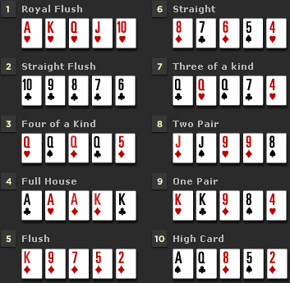**Hands**

A hand is any set of **five** cards.

You may be wondering that during the showdown, each player has 7 cards (5 from the table and 2 hole cards in their hand). Do not worry, the program will automatically find the best (highest valued) set of 5 cards for you in those 7 cards. Here is a list of poker hands, with royal flush (best) being the highest valued, going in descending order.

**Minimums**

For every bet, there is a minimum amount. Periodically throughout the game, this minimum amount will increase to raise the betting stakes and speed up gameplay so it can reach a conclusion sooner. The minimum increases when someone bets more than the original minimum bet – the minimum will increase the previous bet amount. You do not need to worry about minimums as the program will prevent you from placing any illegal bets.

**Maximums**

Since this version of poker is “No-Limit,” players can bet as much money as they want at any given time. It is not uncommon for all players to go “All-In” before the flop.

**User Interface**

*If you are not familiar with the game rules, read the previous section before proceeding any further.*

**Starting the Game**

The game is distributed in a compressed .rar format. After unzipping the file and opening the Texas Holdem folder, **a README file should be opened and the instruction must be followed.** The .exe file for the game can be found at Texas Holdem/Poker Game/Poker Game/bin/debug. But a shortcut has been placed just inside the “Texas Holdem” folder for your convenience. After opening the game, a title screen should pop up. Players have the option to login or create an account to keep track of their prior wins and losses. After starting the game, an options menu should pop-up, in which players can choose their username, number of players, computer difficulty and the buy-in amount. The buy-in amount (50,000 to 500,000) is the amount of money the player wishes to begin with.

**The User Interface**

The game interface is quite simple. There are 2-4 players surrounding a poker table playing poker. Each player is represented by a panel with their name on it. Hence, the player’s hole cards will be found on top of the panel (1). Under the player’s name will be a message showing their most recent action (call, bet, fold, etc.) (2). Under the player panel is the amount of money they have. (3) This value is subject to change due to the nature of the game. At the center of the table are card slots for community cards. (4)

At the top right corner of the interface you can see the difficulty of the AI, the blind amounts (will increase every 10 matches), and the amount of money the players have put inside the pot. (5)

When it is your turn, betting options will appear as buttons in the bottom right corner of the interface. (6) Not seen in the diagram below.

See the diagram below for a visual representation…

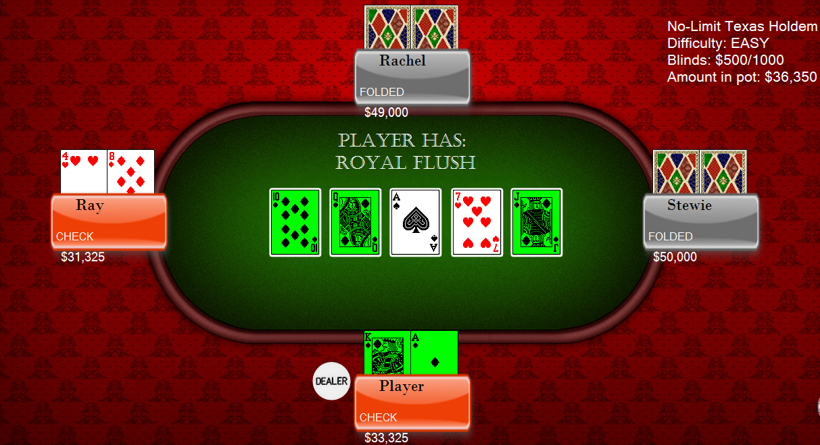

6

5

4

3

2

1